MainActivity.java

Name: Shamsheer Rahiman  
Roll No: J050  
Android App Development  
Assignment 3

package com.example.skull_intent;  
  
import androidx.appcompat.app.AppCompatActivity;  
  
import android.content.Intent;  
import android.os.Bundle;  
import android.view.View;  
import android.widget.Button;  
  
public class MainActivity extends AppCompatActivity {  
  
 @Override  
 protected void onCreate(Bundle savedInstanceState) {  
 super.onCreate(savedInstanceState);  
 setContentView(R.layout.*activity_main*);  
  
 Button homebtn, aboutusbtn, coursesbtn;  
  
 getSupportActionBar().hide();  
  
 homebtn = findViewById(R.id.*homebtn*);  
 aboutusbtn = findViewById(R.id.*aboutusbtn*);  
 coursesbtn = findViewById(R.id.*coursesbtn*);  
  
 Intent home = new Intent(MainActivity.this, HomeActivity.class);  
 Intent aboutus = new Intent(MainActivity.this, AboutUsActivity.class);  
 Intent courses = new Intent(MainActivity.this, CoursesActivity.class);  
  
 aboutus.putExtra("abtit","We are a school filled with glorious purpose and electrifying opportunities");  
 home.putExtra("intro","Welcome to School of Awesome!");  
 home.putExtra("placement","100% placement guaranteed!");  
 courses.putExtra("course1","B. Tech Defence Against the Dark Arts");  
 courses.putExtra("course2","MBA Tech Alchemy");  
  
 homebtn.setOnClickListener(new View.OnClickListener() {  
 @Override  
 public void onClick(View view) {  
 startActivity(home);  
 }  
 });  
  
 aboutusbtn.setOnClickListener(new View.OnClickListener() {  
 @Override  
 public void onClick(View view) {  
 startActivity(aboutus);  
 }  
 });  
  
 coursesbtn.setOnClickListener(new View.OnClickListener() {  
 @Override  
 public void onClick(View view) {  
 startActivity(courses);  
 }  
 });  
  
 }  
}

activity_main.xml

<?xml version="1.0" encoding="utf-8"?>  
<LinearLayout xmlns:android="http://schemas.android.com/apk/res/android"  
 xmlns:app="http://schemas.android.com/apk/res-auto"  
 xmlns:tools="http://schemas.android.com/tools"  
 android:layout_width="match_parent"  
 android:layout_height="match_parent"  
 android:orientation="vertical"  
 android:gravity="center"  
 android:background="@color/black"  
 tools:context=".MainActivity">  
  
  
 <ImageView  
 android:src="@drawable/skull"  
 android:layout_width="300dp"  
 android:layout_height="200dp"/>  
 <Button  
 android:id="@+id/homebtn"  
 android:layout_width="250dp"  
 android:layout_height="wrap_content"  
 android:text="HOME"  
 android:textSize="20dp"  
 android:textAlignment="textStart"  
 android:layout_marginTop="20dp"  
 android:backgroundTint="@color/teal_700"/>  
 <Button  
 android:id="@+id/aboutusbtn"  
 android:layout_width="250dp"  
 android:layout_height="wrap_content"  
 android:text="ABOUT US"  
 android:textSize="20dp"  
 android:textAlignment="textStart"  
 android:backgroundTint="@color/teal_700"/>  
 <Button  
 android:id="@+id/coursesbtn"  
 android:layout_width="250dp"  
 android:layout_height="wrap_content"  
 android:text="Courses"  
 android:textSize="20dp"  
 android:textAlignment="textStart"  
 android:backgroundTint="@color/teal_700"/>  
  
  
</LinearLayout>

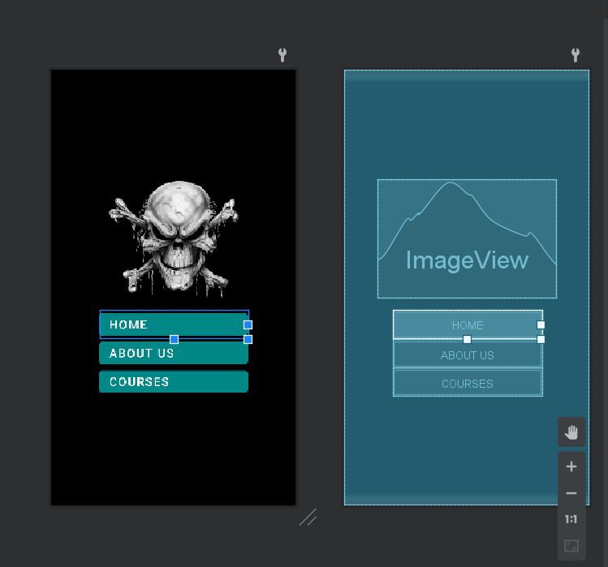

HomeActivity.java

package com.example.skull_intent;  
  
import androidx.appcompat.app.AppCompatActivity;  
  
import android.content.Intent;  
import android.os.Bundle;  
import android.widget.TextView;  
  
public class HomeActivity extends AppCompatActivity {  
  
 @Override  
 protected void onCreate(Bundle savedInstanceState) {  
 super.onCreate(savedInstanceState);  
 setContentView(R.layout.*activity_home*);  
  
 TextView tv1, tv2;  
 Intent fromHome = getIntent();  
  
 getSupportActionBar().setTitle("Home");  
  
 String intro = fromHome.getStringExtra("intro");  
 String placement = fromHome.getStringExtra("placement");  
  
 tv1 = findViewById(R.id.*tv1*);  
 tv2 = findViewById(R.id.*tv2*);  
  
 tv1.setText(intro);  
 tv2.setText(placement);  
  
  
 }  
}

activity_home.xml

<?xml version="1.0" encoding="utf-8"?>  
<LinearLayout xmlns:android="http://schemas.android.com/apk/res/android"  
 xmlns:app="http://schemas.android.com/apk/res-auto"  
 xmlns:tools="http://schemas.android.com/tools"  
 android:layout_width="match_parent"  
 android:layout_height="match_parent"  
 tools:context=".HomeActivity"  
 android:background="@color/black"  
 android:gravity="center"  
 android:orientation="vertical">  
  
 <TextView  
 android:id="@+id/tv1"  
 android:layout_width="wrap_content"  
 android:layout_height="wrap_content"  
 android:textColor="@color/white"  
 android:text="@string/hometxt1"  
 android:textSize="25dp"  
 android:layout_marginBottom="50dp"/>  
 <TextView  
 android:id="@+id/tv2"  
 android:layout_width="wrap_content"  
 android:layout_height="wrap_content"  
 android:textColor="@color/white"  
 android:text="@string/hometxt2"  
 android:textSize="25dp"/>  
  
  
</LinearLayout>

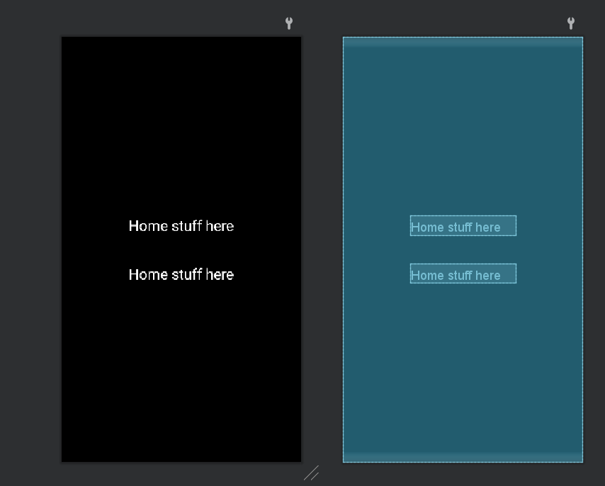

AboutUsActivity.java

<?xml version="1.0" encoding="utf-8"?>  
<LinearLayout xmlns:android="http://schemas.android.com/apk/res/android"  
 xmlns:app="http://schemas.android.com/apk/res-auto"  
 xmlns:tools="http://schemas.android.com/tools"  
 android:layout_width="match_parent"  
 android:layout_height="match_parent"  
 tools:context=".HomeActivity"  
 android:background="@color/black"  
 android:gravity="center"  
 android:orientation="vertical">  
  
 <TextView  
 android:id="@+id/tv1"  
 android:layout_width="wrap_content"  
 android:layout_height="wrap_content"  
 android:textColor="@color/white"  
 android:text="@string/aboutustxt1"  
 android:textSize="25dp"/>  
  
  
</LinearLayout>

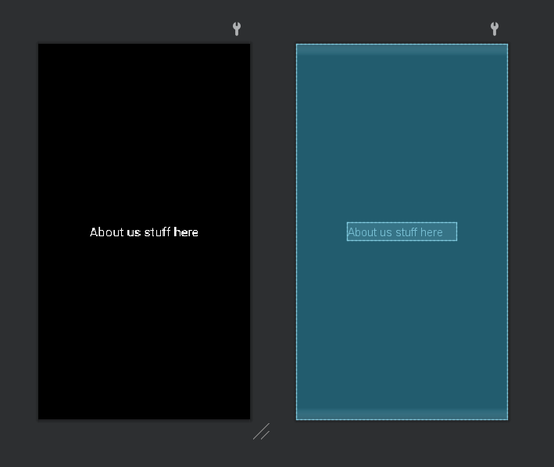

CoursesActivity.java

package com.example.skull_intent;  
  
import androidx.appcompat.app.AppCompatActivity;  
  
import android.content.Intent;  
import android.os.Bundle;  
import android.widget.TextView;  
  
public class CoursesActivity extends AppCompatActivity {  
  
 @Override  
 protected void onCreate(Bundle savedInstanceState) {  
 super.onCreate(savedInstanceState);  
 setContentView(R.layout.*activity_courses*);  
  
 getSupportActionBar().setTitle("Courses");  
  
 Intent fromCourses = getIntent();  
 TextView tv1, tv2;  
 String str1 = fromCourses.getStringExtra("course1");  
 String str2 = fromCourses.getStringExtra("course2");  
  
 tv1 = findViewById(R.id.*tv1*);  
 tv2 = findViewById(R.id.*tv2*);  
  
 tv1.setText(str1);  
 tv2.setText(str2);  
 }  
}

activity_courses.xml

<?xml version="1.0" encoding="utf-8"?>  
<LinearLayout xmlns:android="http://schemas.android.com/apk/res/android"  
 xmlns:app="http://schemas.android.com/apk/res-auto"  
 xmlns:tools="http://schemas.android.com/tools"  
 android:layout_width="match_parent"  
 android:layout_height="match_parent"  
 tools:context=".HomeActivity"  
 android:background="@color/black"  
 android:gravity="center"  
 android:orientation="vertical">  
  
 <TextView  
 android:id="@+id/tv1"  
 android:layout_margin="25dp"  
 android:layout_width="fill_parent"  
 android:layout_height="wrap_content"  
 android:textColor="@color/white"  
 android:text="@string/coursetxt1"  
 android:textSize="25dp"  
 android:layout_marginBottom="50dp"/>  
 <TextView  
 android:id="@+id/tv2"  
 android:layout_margin="25dp"  
 android:layout_width="fill_parent"  
 android:layout_height="wrap_content"  
 android:textColor="@color/white"  
 android:text="@string/coursetxt2"  
 android:textSize="25dp"/>  
  
  
</LinearLayout>

